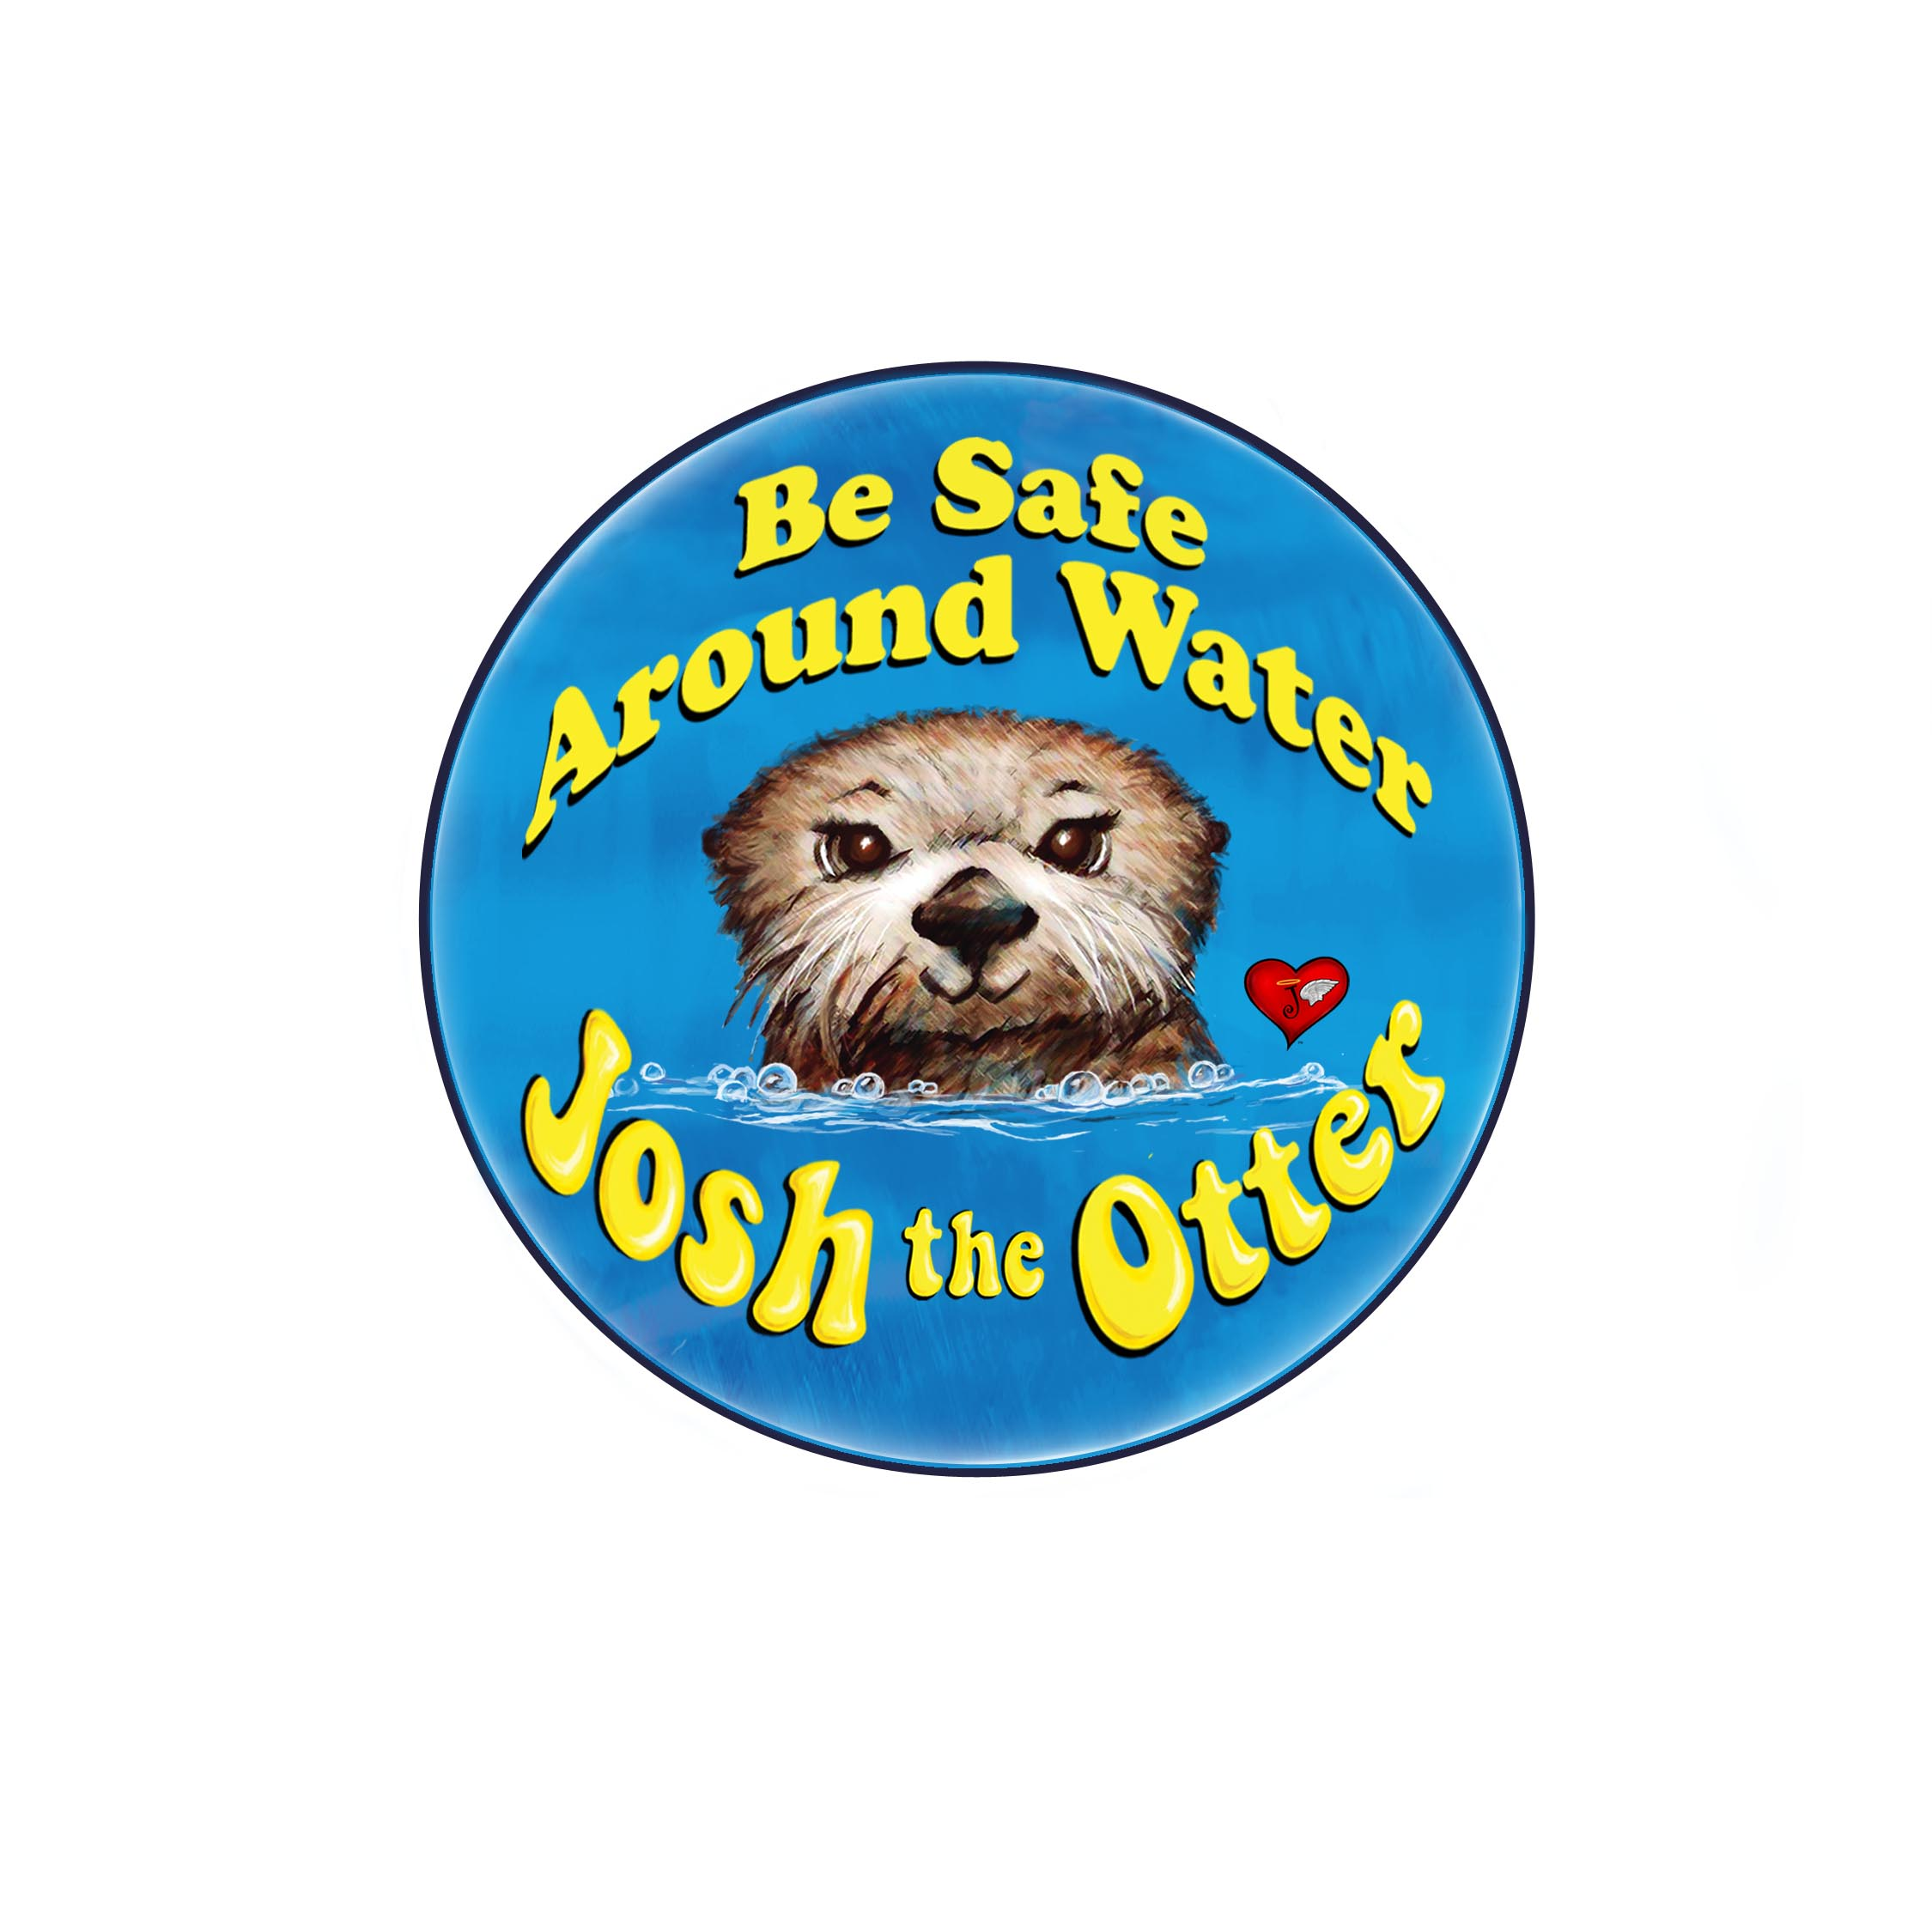

Media Contact: (please feel free to change contact information)
Blake Collingsworth
blake@joshtheotter.org
(c) 402-730-5838
402-613-5555

Partners in Drowning Prevention

{City, State}—On {Month Date, 20**} the {{Name of your Rotary Club, civic group or organization leader} brought {or is bringing} the Josh The Otter Water Safety and Literacy Project to {Name of School, School District, or Club project location}. The energetic classroom program promotes water safety and drowning prevention through the “Josh The Baby Otter” book. The book was written to teach children to “stay away from water unless with an adult and to always swim with a buddy.”

The {Name of your Rotary Club, civic group or organization leader} partners with the drowning prevention nonprofit that created the program, the Joshua Collingsworth Memorial Foundation (JCMF). JCMF with the Josh The Otter program has been nationally recognized for their partnership work with organizations such as Rotary International.

From the coast of eastern Florida to the shores of Hawaii and the tip of Alaska and Canada, the message of Josh The Otter is spreading quickly! Rotarians across the country and even the world are hearing the life-saving message and are excited at the positive changes that a partnership between Josh The Otter and Rotary International can bring to communities everywhere. Since 2010, Rotarian’s have distributed thousands of Josh The Baby Otter books and everyday more clubs starting their own Josh The Otter Literacy and Water Safety Projects. Currently, over 40 U.S. states and several countries such as Pakistan, Brazil, Virgin Island and Canada are pursuing the project within their own clubs. With drowning the leading cause of unintentional death to children all over the world, Rotarians are helping to save thousands of lives.

Joshua Collingsworth Memorial Foundation (JMCF), Lincoln Nebraska

Parents Blake and Kathy Collingsworth honor the memory of their two-year-old son Joshua, who died on June 4, 2008 after falling into the family pool three days earlier. They believed they had every safety precaution in place, but the reality is that a drowning can occur in mere moments. After losing Joshua, they felt compelled to help reduce the dramatic numbers of death by drowning that occur in our country and around the world. The Joshua Collingsworth Memorial Foundation was created in July of 2008 to serve as a catalyst to strengthen water safety awareness and create an early childhood education program. Their goal is to empower children to be safe in and around all bodies of water to prevent similar tragedies. The Josh The Otter Water Safety and Awareness Project is dedicated to teaching young children about water safety through the use of Josh The Otter a book written by Blake Collingsworth.
The book has now been translated into twelve languages and has been published in Spanish, Urdu, and Portuguese with the hopes to reach even more. The foundation and its partners have distributed nearly 250,000 books and have reached over one million children. The program has been presented in classrooms, community centers, zoos, aquatic centers, and childcare facilities around the world.

1.2 million people around the world die by drowning every year that is more than two persons per minute. (International Life Saving Federation)

Drowning is preventable. Let’s not let a tragedy necessary to alert people to consider water safety and awareness www.joshtheotter.org

Joshua Collingsworth Memorial Foundation is a qualified IRS 501 © (3) organization

